Customer Shopping Behavior Analysis – Project Report

1. Introduction
This project focuses on understanding how customers shop, what influences their purchasing decisions, and how different demographic and behavioral factors impact overall sales. Using a dataset of 3,900 purchase records, this study identifies trends in spending habits, product choices, subscription patterns, and customer loyalty.The insights derived support better decision-making for marketing, product strategy, and customer retention.

2. Dataset Overview
The dataset includes 18 attributes representing customer profiles, transaction details, and shopping behavior.
Key data fields include:
- Customer demographics: Age, Gender, Location, Subscription Status
- Purchase information: Product, Category, Purchase Amount, Season, Size, Color
- Behavior indicators: Discount Applied, Promo Code Used, Shipping Type, Review Rating
- Missing data: 37 missing ratings, later treated during preprocessing
The dataset size and variety allow analysis across demographics, product categories, and transaction types.

3. Data Preprocessing & Python-Based Exploration
Data cleaning and preparation were done using Python.

3.1 Initial Checks
- Loaded dataset using pandas
- Used .info() and .describe() to understand structure and statistical summary
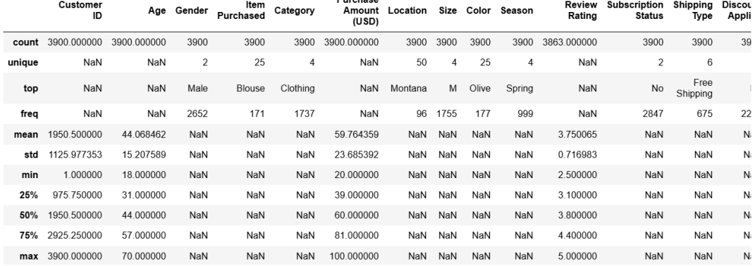
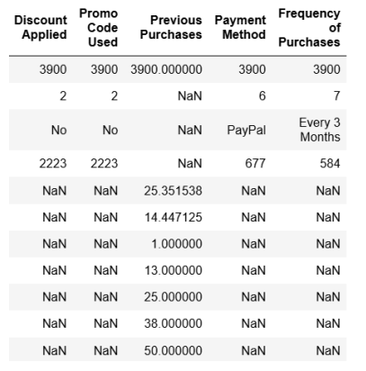

3.2 Handling Missing Values
- Identified missing values in Review Rating
- Imputed missing ratings using median rating of each product category, ensuring consistency
(Reference: Missing value description on page 1–2 of the uploaded file
Customer Shopping Behavior Anal…)

3.3 Column Standardization
- Converted column names to snake_case for easier handling in code

3.4 Feature Engineering
- Created age_groups (e.g., Young Adult, Middle-aged)
- Generated purchase_frequency_days to measure shopping intervals

3.5 Data Cleaning Decisions
- Removed promo_code_used after identifying overlap with discount usage

3.6 PostgreSQL Integration
- Final cleaned DataFrame imported into PostgreSQL for SQL-based analysis

4. SQL Analysis & Business Queries
Using PostgreSQL, several analytical queries were executed to extract insights.

4.1 Revenue by Gender
- Compared revenue contribution between male and female shoppers
(Values reflected in page 3 table
Customer Shopping Behavior Anal…)
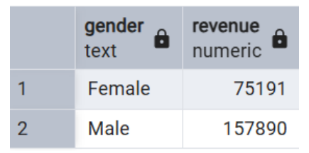

4.2 High-Spending Discount Users
- Identified customers using discounts but still spending above average
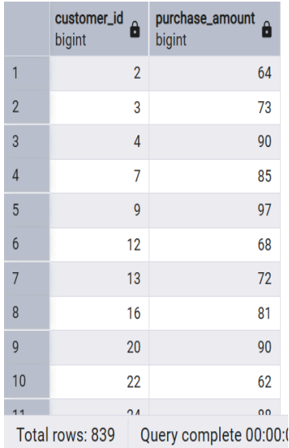

4.3 Top 5 Highest-Rated Products
Products such as Gloves, Sandals, Boots, Hats, and Skirts showed the highest average ratings
(Table on page 4 shows exact values Customer Shopping Behavior Anal…)
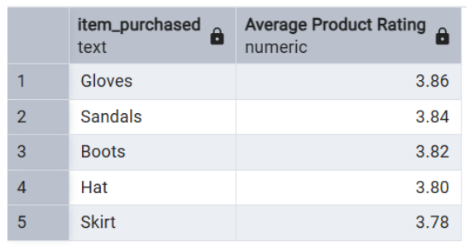

4.4 Shipping Type Analysis
- Compared average order values for Standard vs Express shipping
Page 4 shows that Express purchases had a slightly higher average amount
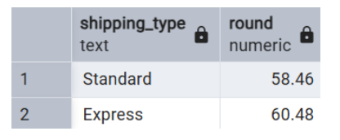

4.5 Subscribers vs Non-Subscribers
- Checked average spend and revenue from both groups
- Non-subscribers were more in number, but subscriber groups showed close average spend
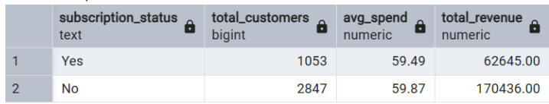

4.6 Discount-Driven Products
- Identified products with the highest percentage of discounted purchases such as Hat and Sneakers

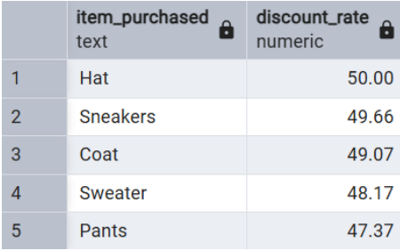

4.7 Customer Segmentation
Segmented users into:
- New
- Returning
- Loyal
As shown on page 5, Loyal customers dominate the dataset.
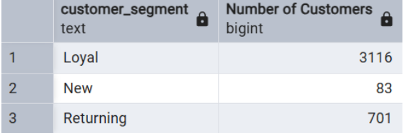

4.8 Top 3 Products per Category
Used ranking logic to list the top-purchased items in each category
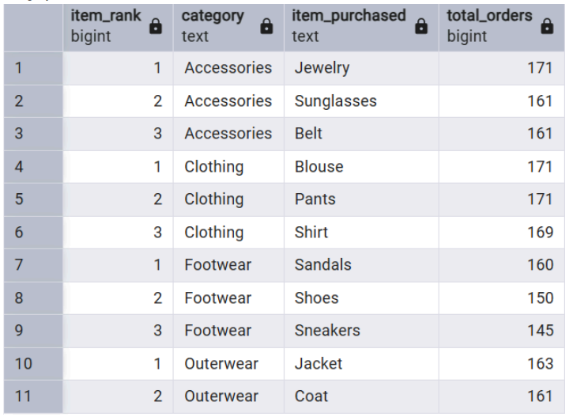

4.9 Repeat Purchases vs Subscription
Checked if customers with >5 purchases tend to subscribe
(Page 6 table used—Yes vs No subscription counts)
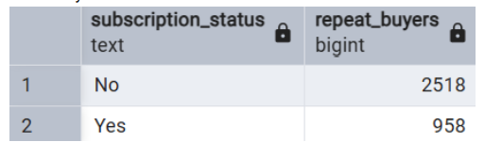

4.10 Revenue by Age Group
- Identified age groups contributing the most revenue
Pages 6–7 indicate Young Adults created the highest revenue share
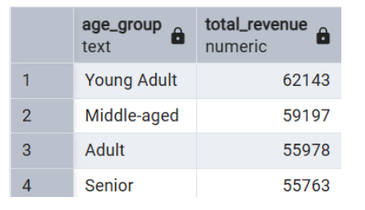

5. Interactive Dashboard in Power BI
A Power BI dashboard was designed to visualize:
- Customer demographics
- Subscription distribution
- Revenue by category
- Sales by age group
- Average purchase amounts
- Review ratings
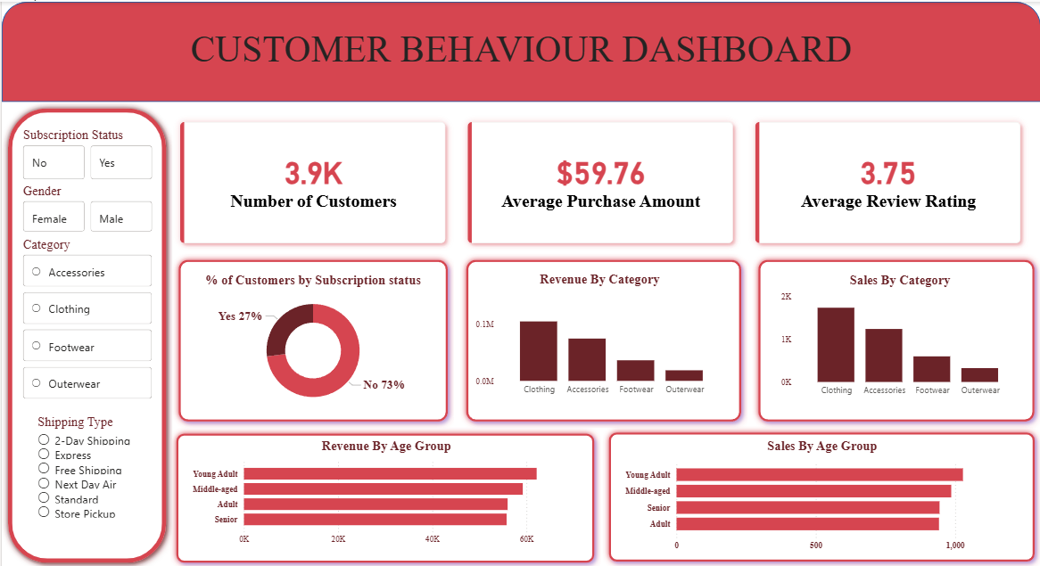
This helps in quick interpretation of trends and customer patterns.

6. Business Insights & Recommendations
Based on the overall analysis, the following recommendations were developed:

6.1 Strengthen Subscription Plans
Subscribers contribute significantly to revenue.
Offer:
- Exclusive discounts
- Early access to new items
- Personalized shopping suggestions

6.2 Enhance Customer Loyalty Program
Loyal customers form the majority.
Introduce:
- Tiered reward programs
- Cashback on repeat purchases

6.3 Adjust Discount Strategy
Products with extremely high discount usage should be reviewed to maintain profits.

6.4 Promote High-Rated & Best-Selling Products
Highlight top-rated and most purchased items in marketing campaigns to drive conversions.

6.5 Age-Based Targeted Marketing
Young Adults and Middle-aged customers show high spending power—target them with category-specific ads.

6.6 Promote Express Shipping Offers
Express shipping customers spend more on average; offering bundled express shipping may boost conversions.

7. Conclusion
This project successfully analyzed customer shopping behavior using Python, SQL, and Power BI.
Key achievements include:
- Cleaning and preparing a multi-feature dataset
- Executing complex SQL queries for behavioral insights
- Building a structured dashboard for visualization
- Delivering actionable business recommendations
The study demonstrates how data analytics can significantly improve strategic decisions in retail, particularly around customer retention, product promotion, and revenue optimization.

